**Title**

**Impaired cortical oxytocin signaling prevents mice from entering stable social cliques**

**Authors**

Sarah Ghanayem1,2,#, Corentin Nelias1,2,#, David Wolf1,2, Marcel Moor1, Max F. Scheller1, Carla Filosa1, Valery Grinevich2, Jonathan R. Reinwald1,2,§, Wolfgang Kelsch1,2,§,*

# shared first authors, § shared last authors, * corresponding author

1 Dept. of Psychiatry and Psychotherapy, University Medical Center Mainz, Johannes-Gutenberg University, Untere Zahlbacher Strasse 8, 55131 Mainz, Germany

2 Dept. of Psychiatry and Psychotherapy, Central Institute of Mental Health, Medical Faculty Mannheim, Heidelberg University, Square J5, 68159 Mannheim, Germany

**New Summary**

The development of stable and reciprocal relationships in societies provides a survival advantage and is necessary for higher-level social functioning. The neurobiological foundations of social network development in mammals are little understood. Oxytocin modulates social cognition and enables the formation of social memories in the cortex. In this study, we investigated how a hypomorphic mutant with reduced oxytocin receptor activity selectively in the anterior olfactory cortex affects self-paced social behavior and the establishment of relationships. Mutants exhibited normotypical microstructures in dyadic interactions and non-social olfactory learning. Mice were housed in sensor-rich environments with few mutants interspersed among wild-type mice to mimic sparse genetic variations in societies. While mutants initially occupied a slightly lower hierarchical position, this difference normalized over time. Also, the density of their social approaches comparable to that of wild-types. Within each society, mice formed "rich clubs" – small, highly social subgroups characterized by mutual stable interactions among the same individuals. Rich club membership depended on the specific group composition, but not kinship. Notably, mutant mice failed to become members of these rich clubs, despite their otherwise typical social behavior. This selective inability to form stable relationships mirrors friendship-related impairments observed in higher-functioning autism spectrum disorders, where individuals engage socially but struggle to form deep, reciprocal bonds. These deficits underscore the role of oxytocin in tuning sensory systems into a state for social processing, with profound implications for an individual's ability to establish stable relationships within social networks.

**From old Summary**

***Impact*** *(44 words)*

In summary, these findings reveal a molecular link between social perception and higher structured social functioning, even when social behaviors remain quantitatively intact. Through these mechanisms, oxytocin impairs the formation of social relations akin of cliques or friendships, an impairment also found in autism spectrum disorder.

*Oder:*

*In summary, these results show a molecular link between cortical endophenotypes and higher social functioning, even when social behavior remains quantitatively intact. Through these mechanisms, oxytocin facilitates the formation of social relationships that resemble stable friendships, which are also typically impaired in high-functioning autism.*

**Introduction**

Social interactions are fundamental for the formation and maintenance of structured societies, contributing to survival, cooperation, and overall well-being. The ability to establish stable and reciprocal relationships depends not only on social motivation but also on cognitive and behavioral mechanisms that facilitate mutual interactions. In mammals, structured social relationships emerge through repeated interactions, forming networks where certain individuals preferentially associate with each other. These relationships can be dyadic or extend to larger social groups and can be either stable or dynamic over time. The formation of such structured networks requires intact social cognition and memory, as well as behavioral adaptations that render interactions mutually reinforcing. Thus, social impairments may not be evident in the frequency of social interactions alone but may only manifest when considering an individual's position within a broader social network.

One particularly informative aspect of social network formation is the emergence of "rich clubs." These highly interconnected social subgroups act as hubs within networks, characterized by frequent, stable, and preferential interactions among specific individuals. While rich clubs have been extensively studied in human social structures and digital networks, their presence and biological underpinnings in animal societies remain poorly understood. Investigating these structures in model organisms offers a unique opportunity to dissect the molecular and neural mechanisms that govern complex social behavior.

The ability to form stable, reciprocal relationships beyond primary kin varies among individuals and is frequently impaired in psychiatric and neurodevelopmental disorders. In higher-functioning autism spectrum disorder, for instance, social difficulties often become apparent in adolescence, when individuals face increasingly complex and dynamic social environments. The inability to establish new, enduring social bonds can have profound consequences for both social integration and economic well-being. However, the neurobiological basis of these impairments remains largely elusive.

One key molecular regulator of social cognition is the neuropeptide oxytocin. Oxytocin has been shown to enhance social memory, facilitate pair bonding, and modulate group cohesion in various species. In humans, it has also been implicated in trust dynamics within social networks. This has led to interest in its potential therapeutic applications for social impairments. However, clinical trials have produced mixed results, indicating that oxytocin’s effects are more nuanced than initially anticipated. A deeper understanding of its function in complex social environments is therefore necessary.

Genetic and neural alterations often manifest differently depending on environmental context. In controlled laboratory conditions, deficits may not become evident, whereas ecologically relevant settings may precipitate them. Vice versa, artificial conditions may isolate deficits, that may be buffered or not relevant in enriched conditions. This discrepancy highlights the need to study social behavior at multiple levels—from individual interactions to network integration—within enriched environments that better capture real-world social complexities.

Recent findings suggest that oxytocin signaling in the anterior olfactory nucleus (AON) plays a crucial role in processing social cues and mediating social recognition. However, it remains unclear whether such deficits can be compensated for in enriched environments and how they affect broader social positioning. In this study, we investigated the behavior of OXTRΔAON mice, a mutant model with reduced oxytocin receptor activity in the AON. By analyzing social behavior hierarchically, we aimed to determine how these mutants function within dynamic social networks, particularly their ability to integrate into rich clubs. Our findings provide novel insights into the role of cortical oxytocin signaling in social network formation and may offer implications for understanding social impairments in neurodevelopmental disorders.

Notes: Clique:

The structural cohesion of the clique is the constant face-to-face interaction between members that can either create or dissolve the group, depending upon the level of interaction. If face-to-face interaction is regularly established, then cohesion between individuals will form.

Notes: In-group:

Research points to unconscious decision-making processes that takes place at the neurological level, where in-group favoritism and out-group bias occurs very early in perception. This process can begin by simply viewing a person's face.[10] Research indicates that individuals are faster and more accurate at recognizing faces of ingroup vs. outgroup members.[11]

Lower activity in the FFA reflects a failure to encode outgroup members at the individual level rather than the categorical level, which comes at the expense of encoding individuating information.[13][14][15] This suggests out-group or unfamiliar faces may not be "faces" with the same intensity as in-group faces.[16]

Notes from natural study issue:

Fig. 1: Making smaller steps by gradually releasing the constraints of our experiments (exp B) makes it more likely that we will find a way to extend or modify current theories to broader ones (theory B), which reflect more ecologically valid assumptions and can explain the new data as well as the old. That process can then continue to new experiments (exp C) and new theories (theory C) that have even higher ecological validity without losing interpretability along the way **-> we actually follow this logic and could serve as an exemplary study of this approach**

**Not observed in our case:**

In the Oxt -/- experiment, mice engaged in excessive aggressive chasing compared to OxtR +/+ groups and exhibited social dominance hierarchies that was not correlated with access to resources (REF).

Takes from this:

* relevance of early social perception for social cohesion
  + we selectively remove this function from oxt actions
  + We leave other functions intact as seen from
    - normal social interaction pattern and
    - quantitatively expression of interaction behaviors in cohorts
* Two main aspects of behavior
  + hierarchy relations and
  + formation of supra-dyadic in-group cohesion (ie. rich clubs).
    - The latter should come with
      * shared group features and
      * specific in-group behaviors and
      * out-group bias
  + Do these two behaviors equally require adult intact early social olfactory perception?
* **What consequences in enriched social environments has a deficit in early social perception?**

**Bullet points:**

**Introduction**

1. Levels of complexity in social behavior
   1. Social relations require structured interactions among individuals.
   2. Each interaction consists of a sequence of behaviors starting with approach that serve, among others purposes, to sample social information.
   3. Social relations are another key aspect that form if there is inherent structure in the interactions. Social relations are captured by social networks where certain animals interact more with each other. These relations can be mutual whereby two animals equally approach each other, or unilateral. They can form stable relations over time or dynamic groups. The relations can be in its simplest form dyadic or larger within a society.
   4. The formation of such structured relationships in social networks requires intact social cognition and memory, but beyond that also interaction behaviors that make mutual interactions attractive to the other.
   5. Therefore, even though social interaction may occur at equal frequencies, they may lack an inherent structure and stability and thus may not produce stable relations.
   6. This means that deficits may be only uncovered when observing an individual’s function in a social network.
2. Rich clubs
   1. Comparatively little is known about social structures in mouse societies and their molecular underpinnings. Social structures that form within societies define by whether
      1. they include or exclude certain animals
      2. they are stable or dynamic
      3. they are based on family bonds or hierarchy in the society
      4. reflect a mutual communication of a member of the structure
      5. how they act on animals outside the structure and how the member of the structure are treated by others.
      6. Internal features of an animal predispose it to become a member of such a structure independent of the specific exact group composition.
   2. Rich clubs are such a social structure that have been extremely useful to understand complex social networks for instance in social media networks. Rich clubs are defined by
      1. A large degree of interaction with the network
      2. A high interconnectivity between its members
      3. Represent hubs or centers in the network
   3. As such rich clubs are a particularly interesting phenomenon that may help to understand social behavior in model organisms with relevance to social behavior in general.

1. Example autism
   1. The ability of forming stable relations beyond the primary family displays a wide continuum in the general population and is frequently impaired in psychiatric and personality disorders.
   2. Deficits for instance in higher functioning autism spectrum disorder many times only become evident during late adolescence when the individual face more complex and dynamic social environments.
   3. These deficits in building stable de novo relations is a key determinant of social and economic wellbeing.
2. Factors modulating the building of de novo social relationships
   1. Currently, there is only a very limited understanding of molecular enablers of higher social functioning and comes with a present lack of biologic treatment options (through pharmacology or neurostimulation).
   2. The neuropeptide oxytocin, as a key modulator of social functioning, forms an exception. It has been identified as enabler of social memory and in some species also for pair-bonding in couples. At a more social network level, it appears to also modulate in-group out-group trust in humans. Such findings supported the use of oxytocin as an experimental treatment.
      1. Yet, the initial enthusiasm dropped with clinical trials suggesting more complex effects. This warrants a better understanding of the function of the oxytocin system especially under complex conditions.
3. Buffering of endophenotypes by enriched environments and time // or // their phenotypic precipitation in complex environments
   1. Genetic alterations or variations of brain function many times display a phenotypic alteration in reductionist conditions in laboratory testing, but are not evident in more naturalistic conditions.
   2. This may have several reasons.
      1. Firstly, enriched environmental conditions may enhance compensatory mechanisms.
      2. Secondly, complex environments require different readouts that capture relevant impairments in particular when already quantitatively simple social behaviors are impaired and the deficits reside mainly in cognitive and memory domains.
      3. These two reasons may co-exist.
      4. Thereby they may give rise to certain endophenotypes, that may only precipitate at more demanding and integrative social functions, but not in the sheer quantitative expression of the (ego-centric) behavior nor in the microscopic sequences of the social interaction per se. Thus, we aimed to also study individual phenotypes at a social network level.
   3. We had recently identified that oxytocin in the olfactory cortex modulates the sensory processing of social cues and is necessary for expressing olfactory recognition of conspecifics under reductionist conditions.
      1. It is however clear whether, in enriched environments, social recognition can be compensated by other cues.
      2. Also it is not clear whether the patterns of exploring others are thereby altered and, potentially, also their positioning social functioning societies.
   4. We therefore analyzed the social interaction behavior of OXTRΔAON mice hierarchically from the elemental sequences of single self-paced interaction events to their structured positioning in ecologic societies. Specifically, we wondered how these mutants interspersed in a normotypic population position themselves in the hierarchy and enter into rich clubs.
4. Not used currently for intro:
   * 1. Single interactions can served to recognize an individual and obtaining information about its state (stress, emotion, etc). These processes are impaired in people with autism spectrum disorders
        1. Example gaze.
     2. Animals have to solve similar tasks, but these atomic motifs are hardly known, especially in smaller rodents. In a few studies, however, it has been observed that behavioral motives can be broken down into sequences of short “atomic” elements (Bob Datta etc). 🡪 Keypoint-MoSeq syllables (from the Datta lab), e.g., *Markowitz JE, Gillis WF, Jay M, Wood J, Harris RW, Cieszkowski R, Scott R, Brann D, Koveal D, Kula T, Weinreb C, Osman MAM, Pinto SR, Uchida N, Linderman SW, Sabatini BL, Datta SR. Spontaneous behaviour is structured by reinforcement without explicit reward. Nature. 2023 Feb;614(7946):108-117. doi: 10.1038/s41586-022-05611-2. Epub 2023 Jan 18. PMID: 36653449; PMCID: PMC9892006.*
   1. Example at the network level:
      1. Individuals may invest similar levels of energy in approaching others, yet it can be effective to very different extents. Structured social relationships arise from interactions that are reciprocated by others. Failure in doing so results in being excluded from friendships. The impaired building of such relationships is a hallmark of autism spectrum disorders and can either from an initial lack of interest or if approach is initially preserved, result in frustration and withdrawal from social interactions over time as often observed.
   2. These two key features are autism network disorders, but barely captured by current animal models.
5. Points that need to introduced:
   1. Oxytocin in social interaction
      1. Important point that both boosting and knock-out tend to increase approach however not producing that the same effect: recognition
   2. Oxytocin in social sensory processing, focus on olfaction
   3. Oxytocin enabled recognition memory
   4. Yet all under reductionist settings:
      1. How does this impact social functioning in complex conditions? For social structure? Or are these deficits compensated by
         1. The ability to sample repeatedly? Or do animals retreat from social interactions as observed in autism spectrum disorder?
         2. Are different domains equally affected like
            1. Social rank
            2. Membership in self-paced rich clubs that require reciprocal voluntary interactions between two and more animals that have to be built in a society?
         3. Touch here compensation and time effects of genotypes

**Results**

**OXTRΔAON Mice During Brief Dyadic Social Interactions**

Social interactions serve as a key mechanism for individuals to sample information and recognize others, with interaction patterns potentially differing between neurotypical individuals and those with deficits in oxytocin signaling. To investigate whether altered OXT in the AON exhibit altered dyadic interaction patterns under reductionist conditions, we conducted brief social encounters in a controlled setting.

We generated a cohort of male OXTRfl/fl mice, injecting half of the animals with an AAV expressing Cre recombinase in the AON pars centralis to induce bilateral OXTR deletion (OXTRΔAON). The other half received an AAV expressing only dtTomato, serving as controls (Fig. 1A-B). One month post-injection, each mouse engaged in a 5-minute social interaction with a novel same-sex C57Bl6 mouse in a fresh cage containing bedding material (Fig. 1C). Behavioral assessments were conducted using a predefined ethogram (Suppl. Table 1), capturing a sequence of interaction behaviors (Fig. 1D).

Analysis of interaction behavior revealed no significant differences between OXTRΔAON mutants and controls. Both groups exhibited comparable duration and frequency of social interaction components (Fig. 1E). Moreover, the sequence of interaction events and transition patterns between specific behaviors were indistinguishable between genotypes (Fig. 1F-G).

In summary, selective deletion of OXTR in the AON did not alter dyadic social interaction behavior in this reductionist setting. However, this absence of a phenotype is likely due to the localized nature of the manipulation, as previous studies have shown that optogenetically induced oxytocin release across broader brain regions modulates the frequency, duration, and sequential pattern of interactions (Linster et al., manuscript under review). These findings suggest that the effects of oxytocin signaling on social interactions may emerge more prominently in complex, network-driven social contexts rather than isolated dyadic encounters.

**Bullet points:**

**OXTRΔAON mice during brief** d**yadic social interactions.**

* 1. *Starting point*:
     1. *One key motivation for initial social interactions is to sample information to recognize others*. *Patterns of such social interactions may differ between neurotypical individuals and those with deficits in oxytocin signaling*.
  2. *Question*:
     1. We therefore initially tested whether OXTRΔAON mice have modified **patterns** of dyadic interaction with novel mice in a reductionist condition.
  3. *Approach*:
     1. We generated a cohort of male OXTRfl/fl mice. Once adult, half of the animals were injected with an AAV expressing Cre in the AON pars centralis, the other half received AAV expressing only dtTomato. We thereby obtained mice with reduced OXTR expression bilaterally in the AON (OXTRΔAON) or matched control mice (Fig. 1A-B).
     2. One month after virus injection, each mouse had a 5 min social interaction with a novel same-sex C57Bl6 mouse in fresh cage with bedding material (Fig. 1C).
     3. Behavioral patterns were assessed with a predefined set of behaviors (Suppl. Table 1). The ethogram illustrates a typical sequence composed of different interaction behaviors (Fig. 1D).
  4. *Result*:
     1. We first tested whether mutants and controls differ in the expression of specific components of interaction behavior. Mutants and controls neither differed in the duration nor frequency when testing the different interaction components (Fig. 1E). Also the sequence of interaction events and the transition patterns between specific behaviors was comparable between mutants and controls (Fig. 1F-G).
  5. *Conclusion*:
     1. In summary, we did not find any genotype effect on the interaction behavior in the reductionist setting when selectively deleting OXTRs in the AON. This was however most likely due to the discrete manipulation in AON as optogenetic OXT release acting in a large set of brain regions under the same conditions modified the frequency, duration and sequence pattern of interactions (Linster et al., manuscript under review).

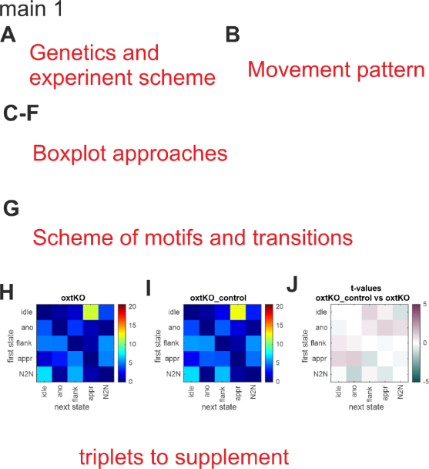 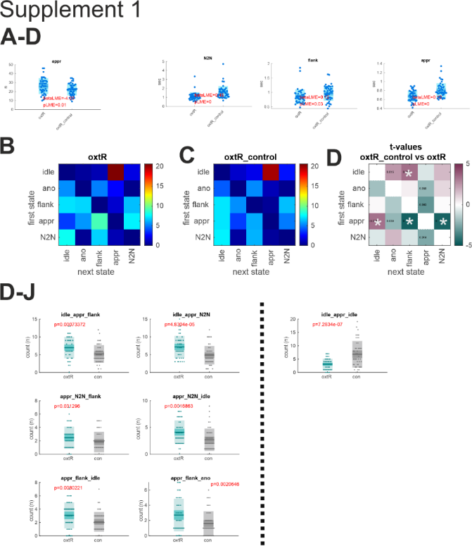

**Non-Invasive Sensor-Rich Tracking of Mouse Colonies**

To assess whether social behavior in OXTRΔAON mice is impaired under more naturalistic and complex conditions, we employed a novel non-invasive sensor-rich environment, the NoSeMaze. This system enables long-term automated tracking of reinforcement learning and social-status-related behaviors in freely interacting mouse societies.

The NoSeMaze consists of a semi-naturalistic environment with an open-field arena and a housing arena containing nesting material and free access to food (Fig. 2A, Suppl. Fig. S2). These arenas are connected via two RFID-equipped tubes, which allow for continuous, automated tracking of individual mice and their interactions. Water access is contingent upon performance in an olfactory stimulus-outcome learning module, where mice perform reinforcement learning trials ad libitum. The module is connected to the open-field arena, ensuring that animals must traverse the RFID-equipped tubes to obtain both food and water, thereby integrating movement, reinforcement learning, and social interactions.

To investigate behavioral traits and their temporal stability, we studied a cohort of 79 male mice (XX OXTRΔAON and XX control mice) that were repeatedly housed in the NoSeMaze. Each group consisted of 9–10 individuals, with 2–3 OXTRΔAON mice interspersed among 7–8 control mice to mimic naturalistic sparse genetic variation. Each mouse was implanted with a subcutaneous RFID chip for continuous automated tracking. Mice were categorized into two age groups: younger adults (16–30 weeks) and older adults (55–97 weeks) (Fig. 2B). Animals lived in the NoSeMaze over multiple three-week rounds, with different social compositions in each session. Between rounds, mice were reassigned to new home cage groups, ensuring novel social dynamics prior to each subsequent NoSeMaze exposure. In total, data from 21 NoSeMaze rounds were analyzed (see Suppl. Table 3).

We first tested the prediction that oxytocin specifically modulates social reinforcement learning while leaving non-social reinforcement learning intact. Since oxytocin primarily facilitates the processing of social sensory cues, non-social learning is likely regulated by other neuromodulatory systems. To examine this, we analyzed olfactory reinforcement learning (RL) performance within the NoSeMaze’s olfactory learning module.

OXTRΔAON and control mice exhibited comparable learning performance across multiple reinforcement parameters. Both groups displayed similar baseline licking rates, as well as equivalent correct hit and rejection rates (alternatively represented as time to criterion; Fig. 2C-E, Suppl. Fig. 3). Furthermore, the time required for learning reversals in conditioned stimulus-unconditioned stimulus (CS-US) contingencies did not differ between genotypes (Fig. 2F).

In summary, the absence of differences in reinforcement learning performance between OXTRΔAON and control mice confirms that OXTR deletion in the AON does not impair olfactory function in non-social tasks. This supports the hypothesis that oxytocin selectively influences social cognition while leaving general sensory learning processes intact.

**Bullet points:**

**Non-invasive sensor-rich tracking of mouse colonies.**

* 1. *Starting point*:
     1. To test whether social behavior in OXTRΔAON mice is impaired under more naturalistic and complex conditions, we performed a second experiment. We therefore used a novel non-invasive sensor-rich maze (NoSeMaze).
  2. Approach:
     1. The NoSeMaze is a complex, semi-naturalistic environment designed for long-term automated assessment of reinforcement learning and social-status-related behaviors in mouse societies (Fig. 2a). The NoSeMaze contains an open field arena and a housing arena with nesting material and free access to food (Fig. 1a, Suppl. Fig. S2). The arenas are connected by two RFID-equipped tubes, allowing automated tracking of social interactions. Access to water is provided via the olfactory stimulus-outcome learning module, in which mice perform trials ad libitum to meet their water needs. The module is connected to the open-field arena, requiring mice to regularly cross the tubes to ensure both food and water intake.
     2. We investigated these behavioral traits and their temporal stability in a large population of 79 male mice (xx OXTRΔAON and xx control mice) that repeatedly lived in the NoSeMaze. 2 to 3 OXTRΔAON mice were interspersed with 7 to 8 matched control mice in each group. Each mouse was equipped with a subcutaneous RFID chip for individual identification and automated tracking prior to experimentation. The study population comprised two age groups: younger (16-30 weeks) and older adults (55-97 weeks) (Fig. 2b). Mice lived over multiple rounds in the NoSeMaze in groups of 9-10, with different social constellations across sessions (Fig. 2b, see also Suppl. Table 2). Before the start of the experiment, mice were housed in groups of three to four in their home cages, with regular shuffling of group composition to ensure familiarity among potential cohort members. Up to four NoSeMazes operated in parallel, with each session round spanning three weeks. Between rounds, mice were reassigned to different home cage groups, facilitating new social dynamics before subsequent NoSeMaze rounds. This allowed us to test which behaviors depend on specific group configurations. In total, data from 21 NoSeMaze rounds were analyzed for this project (see also Suppl. Table 3).
  3. Results:
     1. We first tested the prediction that OXT only matters to social but not to non-social reinforcement learning as OXT functions to set the sensory system in a state for social processing, a job that is taken in non-social learning by other neuromodulators.
     2. We observed in the olfactory RL module of the NoSeMaze that OXTRΔAON and control mice performed similarly in most learning features. The had similar baseline licking rates as well as correct hit and rejection rates (replace *alternatively here by time to criterion,* Fig. 2C-E, Suppl. Fig. 3). Also with regards to the time that it took for learning the reversal in CS-US contingencies were comparable (Fig. 2F).
  4. *Conclusion*:
     1. In summary, the lack of difference in performance and learning parameters between WT and OXTRΔAON mice confirms proper olfactory functioning in non-social tasks.

Notes: for RL:

* + 1. Statistics: Permutation test and LME (accounting for the repetitive factor) between WT and OXTRΔAON mice.
    2. LME: No differences in **correct_rejection_rate, correct_hit_rate, baseline_rate_mean_omitfirst**, cs_minus_modulation_min, cs_plus/minus_switch_latency_at_cs_rev2/3/4
    3. Higher CS+ modulation peak in OXTRΔAON mice than in WT mice.
    4. *Should we do multiple comparison correction here, than the higher CS+ modulation max in OXTRΔAON mice (ii.) would not survive? Is it of interest at all, or should we focus on the performance (correct rej./hit rate and if necessary the switch latencies?)*

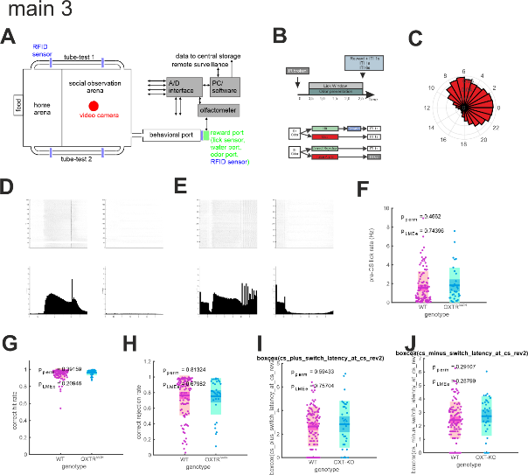 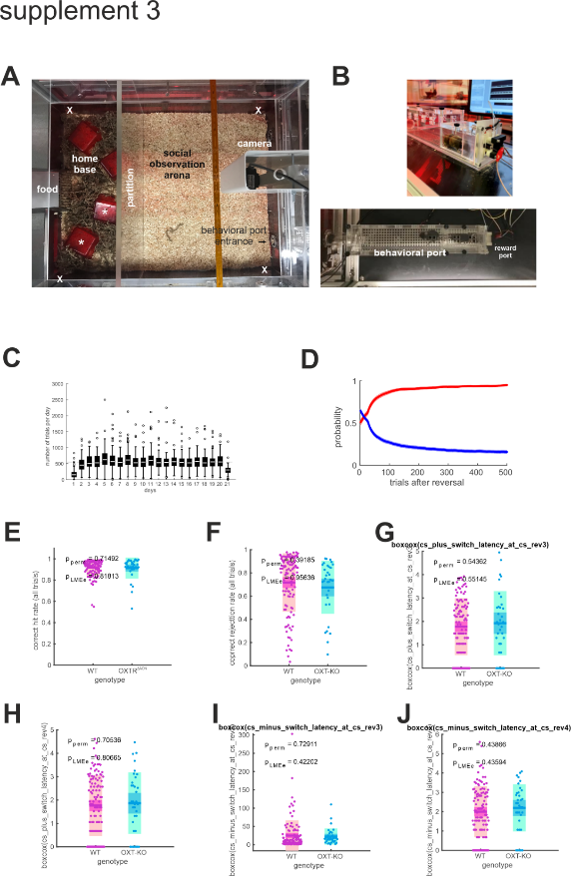

### OXTRΔAON Mice Gain a Normal Social Rank Over Time

Social networks can emerge from various underlying mechanisms, including voluntary mutual interactions and incidental encounters. Voluntary interactions, such as self-paced mutual approaches, require both initiating and receiving individuals to engage reciprocally over time. In contrast, incidental encounters, such as those occurring in the tubes equipped with RFID-readers, involve competitive decision-making, where one individual must yield to another, establishing social rank hierarchies. Given that oxytocin modulates social cognition and olfactory-based recognition, its role may differ across these social domains.

To assess whether OXTRΔAON mice differed in social rank acquisition, we analyzed tube-based social rank competitions in the NoSeMaze. Social rank was quantified using the David’s Score (DS), a measure derived from transitive dyadic interactions that form a hierarchical structure (Fig. 3A-B). During the first two weeks (days 1–14), OXTRΔAON mice exhibited a significantly lower social rank, driven by a reduced number and fraction of wins in tube encounters (Fig. 3C, Suppl. Fig. 3). The z-scored David’s Score showed a trend toward significance (p = 0.06). Notably, total detections at the RFID antennas and the number of social interactions per day did not differ between genotypes, ruling out general activity differences as a confounding factor.

When analyzing the first week separately (days 1–7), OXTRΔAON mice demonstrated a lower z-scored David’s Score and a reduced number and fraction of wins (Fig. 3D, Suppl. Fig. 3). These differences were most pronounced early in the competition phase, suggesting an initial disadvantage in social rank acquisition. By the second week (days 8–14), differences in social rank between OXTRΔAON and control mice diminished. While trend-level effects persisted in the linear mixed-effects models (LMEs) for the number and fraction of wins, there were no longer significant differences in the z-scored David’s Score or overall social rank (Fig. 3E, Suppl. Fig. 3). By the third week (days 15–21), all measures of social rank, including the z-scored David’s Score, total social rank, and number and fraction of wins, showed no significant differences between OXTRΔAON and control mice (Fig. 3F, Suppl. Fig. 3). This suggests that although OXTRΔAON mice initially struggle to establish social dominance, they eventually integrate into the social hierarchy at levels comparable to wild-type controls.

To further examine whether OXTRΔAON mice exhibited differences in competitive or aggressive social behaviors, we analyzed chasing interactions within NoSeMaze groups (Fig. 3G. Direct comparisons between genotypes revealed no significant differences in either active chasing of others or the frequency of being chased (Fig. 3H, Suppl. Fig. 3). This indicates that voluntary competitive interactions, a component of social dominance behavior, were expressed similarly between OXTRΔAON and control mice.

Overall, OXTRΔAON mice initially occupied slightly lower social ranks but normalized their positioning over time. The absence of persistent social rank differences suggests that oxytocin signaling in the AON may influence early social competition learning but is not required for long-term social rank stabilization. Additionally, volitional chasing behavior was unaffected, reinforcing the idea that general social competitiveness remains intact in OXTRΔAON mice despite early deficits in hierarchical positioning.

**Bullet points:**

**OXTRΔAON mice gain a normal social rank**

1. *Starting point*:
   1. Social networks can build on different bases.
   2. For instances, social interactions based on self-paced mutual approaches are voluntary behaviors and are further confined by the fact that even though one may act, it cannot request that the other will also approach later. Only if these behaviors occur regularly, animals express a volitional mutual interaction.
      1. In a possible scenorio, animals may show similar numbers of approaches to others in societies to any animal in the colony without preference (random behavior) that may not lead to relations (i.e. mutual relation)
      2. In another scenario, a mouse may target specific other animals, but those do not respond in the same manner, again failing to build mutual relations [Corentin where and how can we completely show this? What do we already have? What would we still need?-> **Boxplot showing the portion of symmetric approaches as a function of mutant/wt/RC? We already for that for the RC?**] We will come back to this type of interaction later.
   3. Social encounters can also be incidental. In the NoSeMaze for instance, animals incidentally meet in the tube and a decision has to be made which one lets the other pass and thus subordinates (Fig. 3A). The emerging hierarchy network (Fig. 3B) will reflect the internal state of the animal, but the information about the competitor in the tube. In the NoSeMaze, transitive dyadic hierarchy networks emerge that reflect social rank (Reinwald et al., Biorxiv).
   4. As the chemosensory signals may play variable roles in incidental social rank competitions and volitional more complex social interactions, deficits observed of OXTRΔAON mice may vastly differ.
2. *Question*:
   1. Do OXTRΔAON mice take different social ranks than WT mice? We first tested social rank competitions in the tubes.
3. *Result*:
   1. Day 1-14 (Fig. 3C, Suppl. Fig. 3):
      1. Significantly **lower social rank in OXTRΔAON mice**, driven by **lower number of wins/fraction of wins**. The David’s score (and the z-scored DS) show trend level differences (p = 0.06). Note that the total detections at the antennas and the detections per day do not differ between the two groups (and also not the number of events).
      2. No differences for following rank, trend towards lower fraction of active chasings.
   2. Day 1-7 (Fig. 3D, Suppl. Fig. 3): **Lower z-scored David score, social rank, number/fraction of wins in** **OXTRΔAON mice**
   3. Day 8-14 (Fig. 3E, Suppl. Fig. 3): No significant differences for **z-scored David score** and social rank in OXTRΔAON mice, trend level findings in the LMEs for number/fraction of winners.
   4. Day 15-21 (Fig. 3F, Suppl. Fig. 3): No significant differences for **z-scored David score**, social rank, number/fractions of winners in OXTRΔAON mice
   5. We finally compared chasing between OXTRΔAON and control mice in the groups. Direct comparison revealed no significant difference between genotypes for either active chasing of thers or the frequency of being chased (Fig. 3G, Suppl. Fig. 3).
4. *Conclusion*:
   1. OXTRΔAON mice take initially slightly lower social ranks, which however normalize over time.
   2. The volitional chasing was globally expressed to similar extents in mice with and without OXTR deletion in the AON.

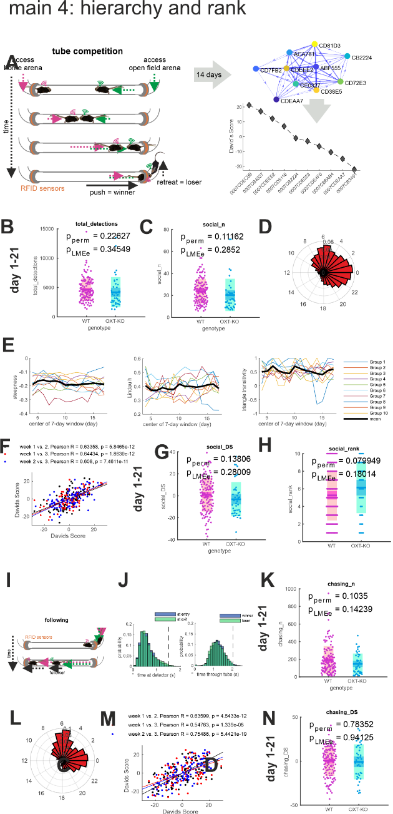 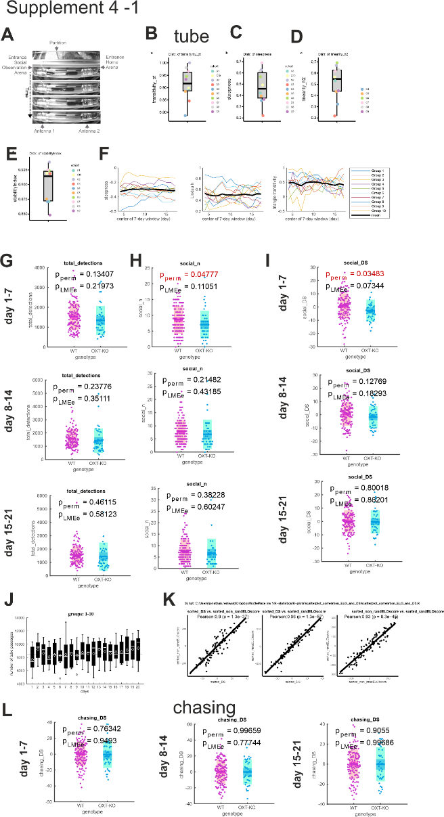

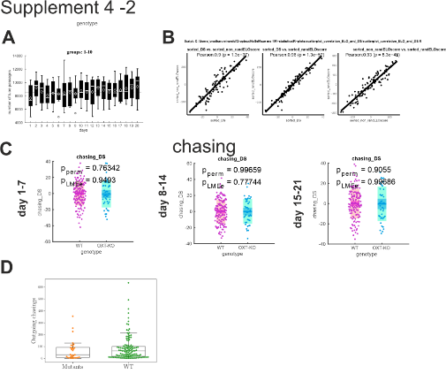

1. **Social interaction in the NoSeMaze.**
   1. *Starting point*:
      1. As introduced above, animals in the society may form structured social relations that reflect in self-paced interactions in the open field.
   2. *Question*:
      1. We therefore wondered whether OXTRΔAON mice display comparable frequencies of approaches and interaction in the open field as wild-types.
   3. *Approach*:
      1. **[JONATHAN]**
      2. Statistics: Permutation test between WT and OXTRΔAON mice for outgoing approaches and chasings, as well as total interactions. WT mice can be subdivided into two categories (RC and non RC members).
   4. *Result*:
      1. **[JONATHAN]**
      2. If one separates WT into RC and non-rc (plotting 3 categories: RC, mutants and others), weakly significant differences (*) are observed between mutants and non-RC members for outgoing approaches. If one only looks at the data in terms of WT vs mutants, no significant differences are observed.
   5. *Conclusion*:
      1. In summary, OXTRΔAON mice show normal approach and interaction frequencies **[not true according to last analyses, or true if RC and non-RC are not separated!!?? True if one plots mutants vs WT (no distinction between RC and non RC) and mostly true otherwise.]**.

**Main Fig. 5:**

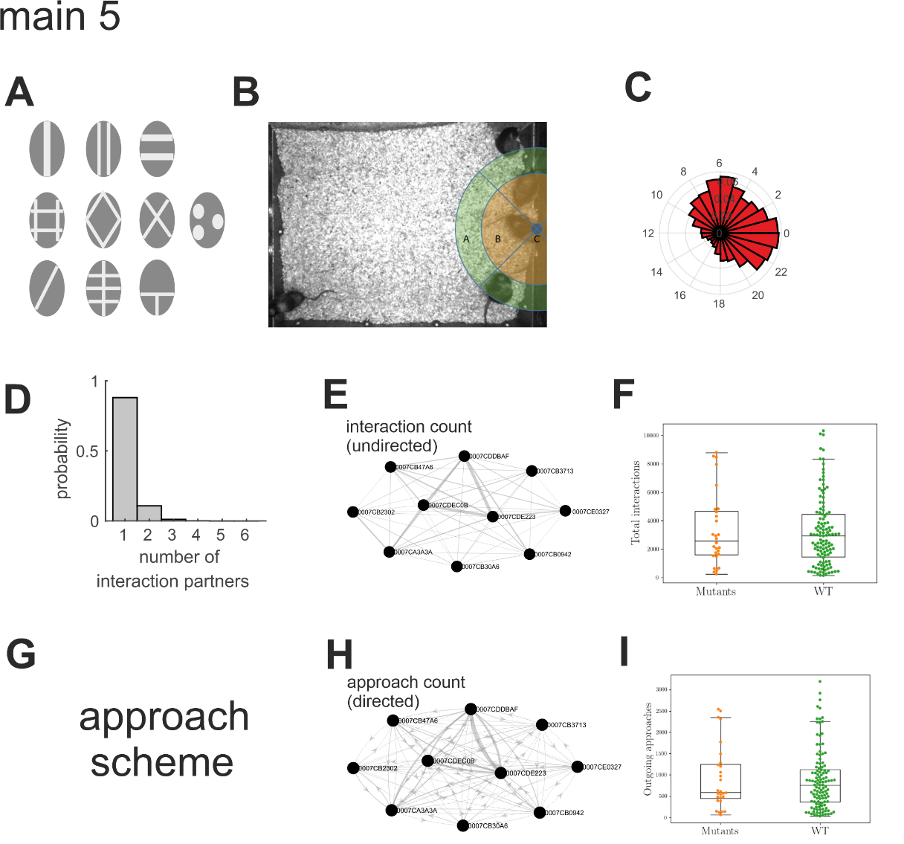

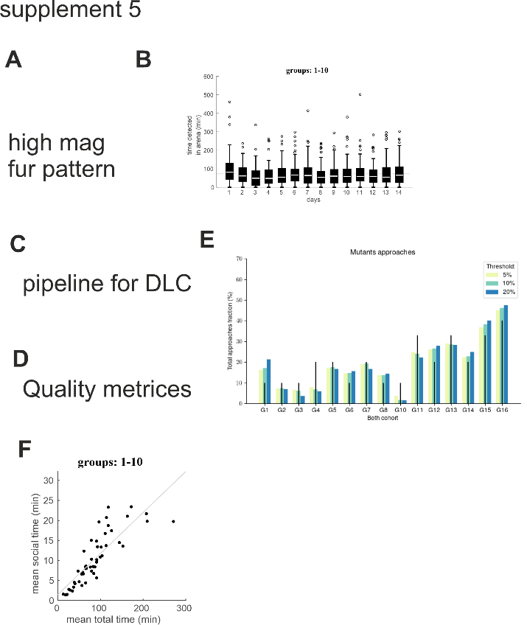

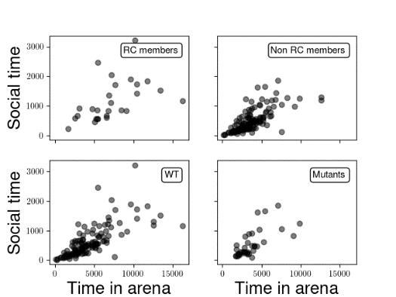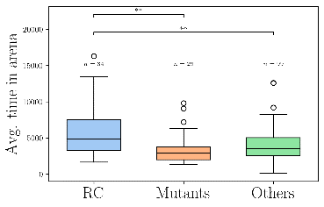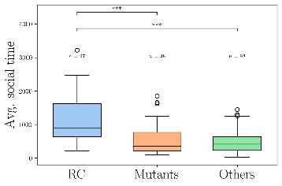

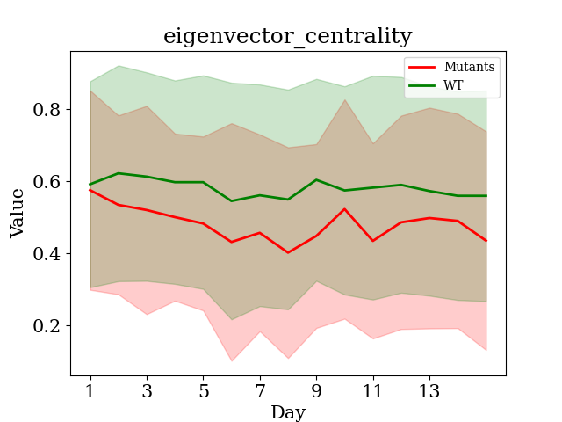

Fig. ?: graph theoritical measurement of centrality

To reveal the presence of higher order interactions, we investigated common graph theoretical measurements of centrality, comparing the scores of OXTRΔAON and WT mice as a function of time. This analysis is shown in Fig. ?. Even though the differences between WT and mutants are not significant on any given day, a consistent trend is observed where the mutants are associated with a lower centrality score. This hints at the fact that a more in depth analysis of the graphs might be necessary.

Until this point we have been mostly concerned with the description of pairwise interactions patterns among mice evolving within the nosemaze. As we have established, OXTRΔAON and WT mice behave similarly in the way they approach and chase each other. However, dyadic interactions alone provide only a partial description of the way mice might collectively behave: within the nosemaze, the mice are part of a social network, and so higher order interaction might arise. It is therefore reasonable to ask if mice form such structured social relationships. Here we are primarily interested in stable higher order social structures, i.e. persisting over extended periods of time. This is important, as the variability of the social activity among mice at different days might induce the observation of connected cliques by random chance.

The graphs representing social interactions in the nosemaze are highly interconnected (fully connected even, for most cohorts), which makes pruning necessary to reduce complexity and reveal the most salient structures. However, common thresholding methods are impractical, because the average level of activity (e.g. number of approaches, encounter duration…) shows great variability across cohorts. For this reason, we pruned the graphs using mutual nearest neighbors, retaining only the connections between nodes that were at most mutual nearest neighbors of 3rd order (see Methods). Within the resulting sparser graphs, we focused on high-degree nodes (k ≥ 3). High degree nodes are of particular interest in network science as they are able to influence the dynamic of the whole network ([**https://doi.org/10.1098/rsbl.2004.0225**](https://doi.org/10.1098/rsbl.2004.0225)).

Following this procedure, we examined the graphs representing the number of interactions between mice in 16 out of the 21 cohorts, excluding the ones for which the video tracking was not good enough to obtain reliable data. In order to reduce variability, we analyzed the social interactions averaged on a three-day basis, meaning that we analysed 5 graphs per cohort with each graph representing the average number of interactions over three days of experiment. An example of the pruned averaged graphs is shown in Fig. 6. We consider that a structure observed in the interaction graphs of a given cohort is stable if it is common to at least 4 out of the 5 averaged graphs.

In most cohorts, we observed the presence of interconnected stable high degree nodes (see Fig. 6) in the interaction graphs, forming pairs or triads. Drawing inspiration from network science **(**[**https://doi.org/10.1038/nphys209**](https://doi.org/10.1038/nphys209)**)** we will refer to these structures as rich clubs. Such stable rich clubs are highly unlikely to persist by random chance: a simple combinatorial analysis reveals that the probability of stability for a rich club across at least four graphs is about $1.{10}^{-5}$ for a pair and $5.{10}^{-7}$ for a triad. We then compared the rich-club members to the rest of the population (see Fig 7 and 8) and noticed salient differences across multiple behavioral aspects. First of all, we notice that rich club members are on average significantly more active than the rest of the colony. Indeed, we observed that the number of interactions and approaches performed by rich club members tend to be 2 to 3 times higher than non-members (Fig. 8D, 8E). This contrast is even starker if we consider how often rich club members tend to chase other mice: on average, they initiate about 4 times more chasings than others (Fig. 8E). In addition to overall higher levels of social activity, rich club members also appear to engage in more reciprocal approaches than the non-club members. To see this, we quantified the number of symmetric approaches performed by rich club members and compared them to the rest of the population. We defined approaches between two mice to be symmetric if the number of outgoing and ingoing approaches differed at most by a factor 1.5. Rich club members approached each other symmetrically 96% of the time (see Fig. 8). In contrast, this proportion was 67,7% for the whole population. Interestingly this difference in reciprocity was not observed for chasing. Finally, we noticed that rich club members tend to score high in hierarchy but that there was also a large variance in the distribution of ranks among them, indicating that a high social rank might help to enter rich clubs but is not strictly necessary. (see Fig. 7)

We also wondered if the existence and properties of the observed rich clubs could be linked to family bounds between mice. Indeed, mice that are former littermates might have a predominance for forming rich clubs. To test this, we ran a bootstrap test (see Methods) comparing the experimentally observed proportion of rich club members that were littermates to the one we would expect by random chance, based on the total number of littermates per cohorts. The results are shown in Fig. 8B, where we see that the experimentally observed proportion of littermates in rich clubs is within the confidence interval of the null hypothesis. This indicates that there is no significant family effect for rich club formation, even though the observed value is appreciably higher than the mode of the distribution.

We then asked ourselves whether rich club membership is a feature that is an intrinsic trait of animals (akin to social rank), or if it is a characteristic of the specific dynamics of the different cohorts. We tested for this by computing how often animals that were included in multiple cohorts were part of the rich club. We compared the experimentally observed value to the proportion we would expect by random chance via a bootstrapping. As can be seen in Fig. 8A, animals that were at least once in the rich club do not have a significantly higher chance of entering it again. This is shown by the fact that the observed number of animals that repeatedly formed the rich club in different cohorts is within the confidence interval of the null hypothesis, and is close to the average value expected by random chance. This finding points at the fact that stable rich clubs are an effect reflecting the specific group dynamic of each cohort and not an intrinsic property of mice.

In summary, we observed the formation of stable interconnected social structures that we call rich clubs in most colonies in the nosemaze. We found that mice in the rich clubs were significantly more active, engaged in more reciprocal interactions, and initiated more chasings than non-members. Owing to the fact that family relationships did not significantly influence rich club formation, and that most mice that entered the club did not integrate it again after randomization, we conclude that stable rich club formation is an emergent property reflecting the dynamic nature of the social interaction within each colony.

1. **Mice form stable rich clubs in the NoSeMaze.**
   1. *Starting point*:
      1. It is however possible that OXTRΔAON mice with impaired social sampling and memory are impaired in forming structured social relations in self-paced interactions.
      2. Such structured social relations should fulfil certain features.
         1. They should be stable over time.
         2. Relations should be mutual in their nature.
         3. They should form higher-order relations among animals and as such, these rich clubs should share other social behaviors than the rest of the colony.
   2. *Question*:
      1. We tested whether such rich clubs are regularly formed in the colonies and fulfill the above criteria.
      2. We also wondered whether
         1. shared family bonds still promotes entering into the rich club as adults.
         2. Rich club membership is a feature that is a trait of animals like social rank that as IxE is preserved when mice with other mice, or specific to the mice in the colony. As it depends on mutual interactions and not only on intrinsic state, it might be, akin of friendships, only be formed under certain conditions.
            1. Related to this, we wondered to which other behaviors rich club members share.
   3. *Approach*:
      1. To reduce complexity, we perform a graph cut based on mutual nearest neighbors (4 mnn) and define the rich club members as the ones having degree > 3. To reduce variability, use we data averaged on a 3 day basis. We define that an animal is part of the stable RC if it was as rich club member at least 4 out of 5 times (on 3 day basis). We quantified how many cohorts presented a stable rich club and tested if the observations can be explained by littermates preferences or social memory after reshuffling via bootstrapping.
      2. We did a permutation test on total number of approaches/chasings from RC members vs WT. We analyzed how stable RC members approach and chase others by ranking them as a function of total number of approaches/chasings and looking at the symmetry of these interactions. We define an approach/chasing to be symmetric if the ingoing and outgoing interaction differ by a factor of at most 1.5.
   4. *Result*:
      1. We observe rich clubs comprising 2 to 3 members(or 4 depending on analysis parameters) that are stable over time (at least 12 out of 15 days) for most cohorts (12 out of 15 cohorts). These stable rich clubs are emergent social structures specific to each cohorts as they cannot be explained easily by littermate preferences (no significant effect) or preference towards previous encounter before reshuffling (also no significant effect)
      2. Members of the stable rich clubs are responsible for most of the approaches and the chasings (in absolute value) and tend to rank somewhat high in the social hierarchy.
      3. Members of the rich club approaches themselves mutually much more than other mice (show comparison of pie charts?).
   5. *Conclusion*:
      1. Mice in the NoSeMaze form stable rich clubs that usually comprise 2 to 3 members.
      2. Entering a rich club in one colony or family relations do not guarantee to become a rich club member in another colony akin of the formation of friendships.
      3. Rich club members however also mutually chase in other more in the tube and have a tendency to be in the upper parts of the hierarchy.
      4. Thus rich clubs form structured higher order relationships.

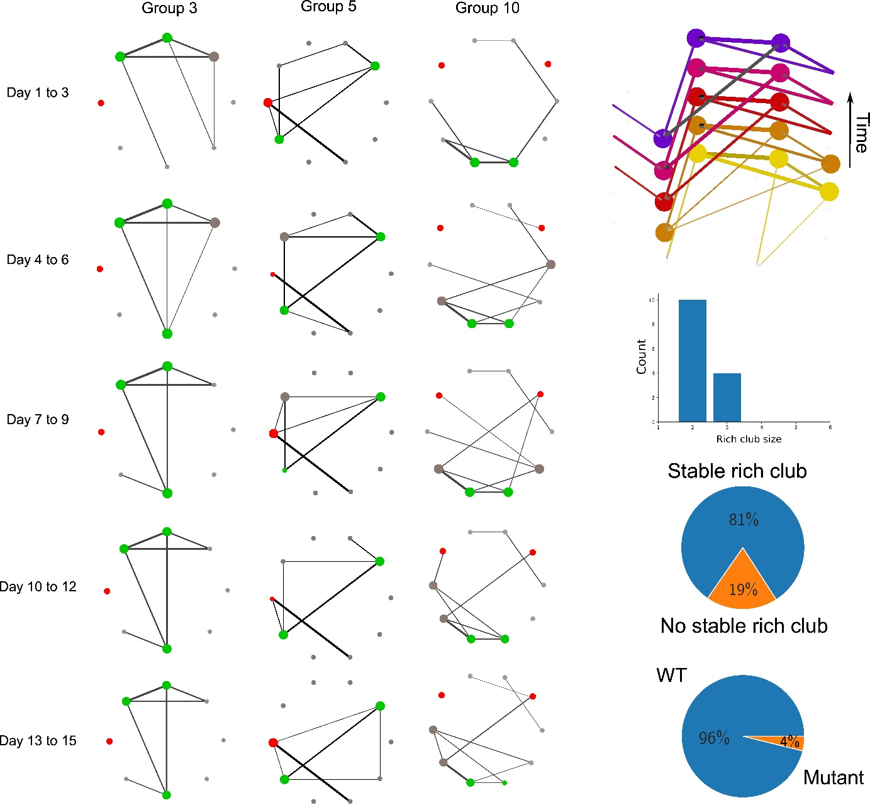

**Main 6: Rich clubs: approach**

Since the formation of rich clubs in colonies appears to be a consequence of higher-order social interactions, a crucial question is whether OXTRΔAON mice are able to enter them or not. Indeed, OXTRΔAON mice have been shown to suffer from social sampling deficit and impaired memory **(citation)** While these deficiencies did not lead to significant differences in the way mice partake in dyadic interactions, it is very well possible that OXTRΔAON mice lack the capacity to engage in more complex social interactions.

To answer this question we compared the number of OXTRΔAON mice that were able to enter the rich club to the one that would be expected by random chance using a bootstrap approach. The results of this test are displayed in Fig. 8C and show that OXTRΔAON mice are considerably less likely to enter the rich clubs than WT mice. The strength of this effect provides compelling evidence that oxytocin receptor (OXTR) signaling plays a crucial role in the formation of lasting social bounds in mice.

1. **OXTRΔAON mice do not enter rich clubs.**
   1. *Starting point*:
      1. OXTRΔAON mice with impaired social sampling and memory.
   2. *Question*:
      1. We therefore wondered whether mutants that still regularly approach others and are approached, form structured higher-order mutual relationships.
   3. *Approach*:
      1. Tested whether observed proportion of mutants in the stable RC is imputable to random chance via bootstrapping.
   4. *Result*:
      1. OXTRΔAON mice are below chance level to enter RC.
      2. Outgoing [also incoming?] chasing, total interactions and approaches are expressed in OXTRΔAON mice as in other non-RC members.
   5. *Conclusion*:
      1. Indeed, OXTRΔAON mice do not form structures social relationships and also behave like non-RC mice with regards to approach densities and chasing.

**Main 7: rich club: features**



8a:

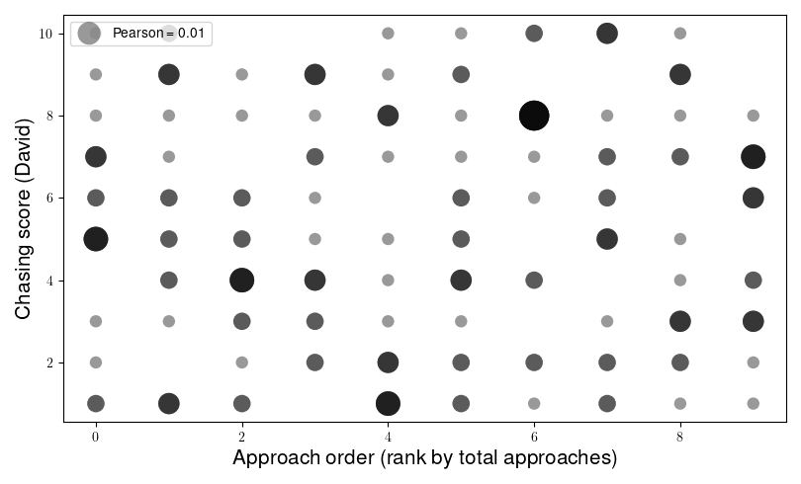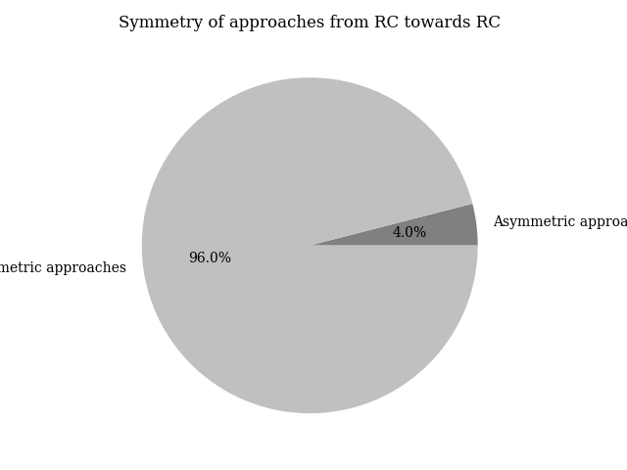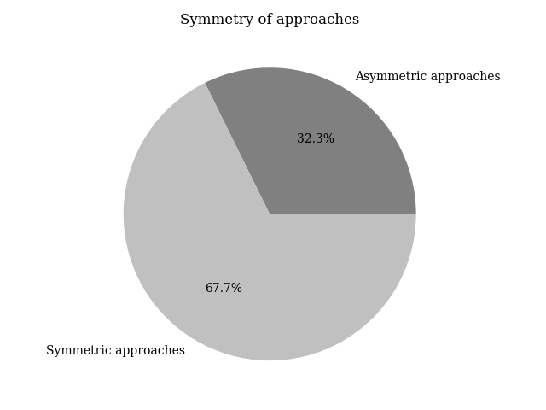

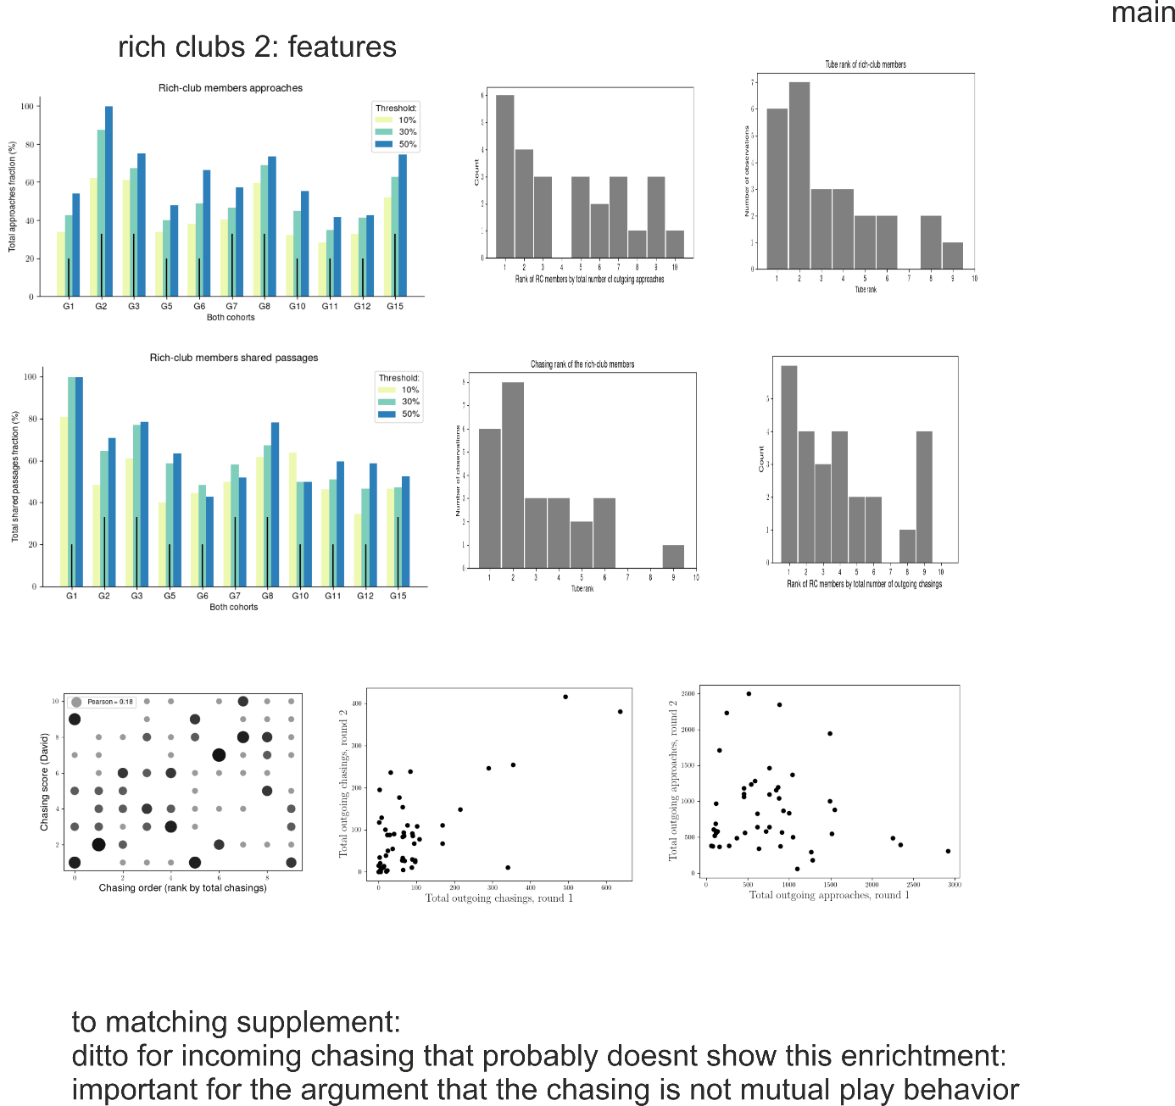r

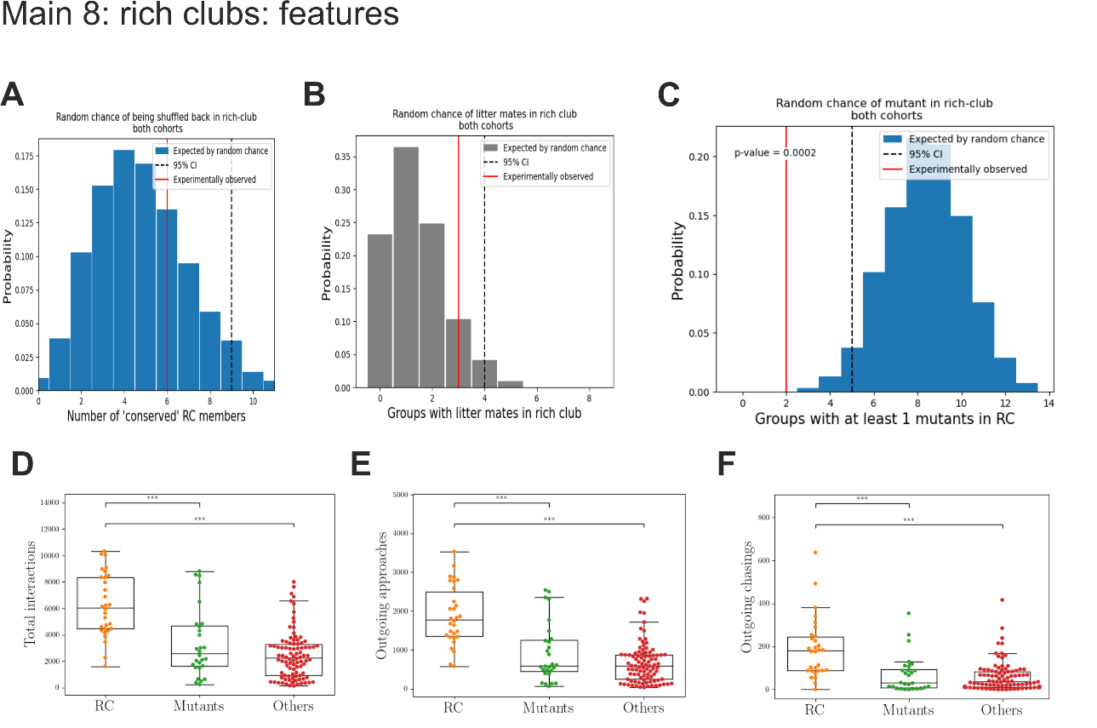

**Discussion**

Our findings provide compelling evidence that oxytocin receptor (OXTR) signaling in the anterior olfactory cortex is crucial for the formation of stable social relationships in mice. Specifically, while OXTRΔAON mutants displayed intact social motivation and dyadic interactions, they failed to integrate into stable, highly interconnected social subgroups, or "rich clubs." These results suggest that oxytocin modulates higher-order social cognition necessary for structured social integration rather than basic social engagement.

### Social Complexity and Genotype-Phenotype Relations

Deciphering genotype-phenotype relationships in social behavior requires investigating interactions at multiple levels of complexity. Reductionist behavioral assays often fail to capture emergent social structures, as genotypic variations may only manifest in ecologically relevant conditions. The NoSeMaze system allowed us to study self-paced interactions in freely moving mouse colonies, providing an opportunity to assess the supra-organismal effects of OXTR dysfunction at the network level. By interspersing a minority of mutants within a wild-type population, we mimicked sparse genetic variations found in natural societies while avoiding artificial shifts in collective behavior. This approach revealed that, despite displaying normal social approach behavior and intact dyadic interaction sequences, OXTRΔAON mutants exhibited profound impairments in forming structured social relationships.

This dissociation between simple social behaviors and higher-order social integration aligns with observations in high-functioning autism spectrum disorder (ASD), where individuals may engage in social interactions yet struggle to form deep, reciprocal bonds. Our results highlight the importance of studying complex behaviors beyond isolated social motifs, as deficits in structured social cognition may not be evident when considering only basic interaction frequencies.

### Structured Social Behavior and Rich Clubs

Rich clubs represent a fundamental aspect of social network organization in both humans and animals, forming stable hubs within social systems. Our findings demonstrate that wild-type mice readily establish rich clubs shortly after being introduced into a social environment and maintain membership over time. However, these structures are not intrinsic to individuals but emerge from group-specific dynamics, as evidenced by the fact that previous rich club members were not more likely to re-enter a rich club when introduced to a new social group. This suggests that structured social bonding is an adaptive and situationally learned process rather than a fixed individual trait.

Notably, OXTRΔAON mutants failed to enter rich clubs despite exhibiting typical social hierarchy positioning. This suggests that rich club formation relies on oxytocin-dependent social learning, reinforcing the notion that stable, reciprocal social bonds require cognitive processes beyond mere social engagement. This distinction between social rank and structured social relations parallels human social hierarchies, where status may facilitate but does not determine the ability to form close, reciprocal relationships.

### Stability and Situational Social Relations

The differential effects of OXTRΔAON deletion on social rank and rich club membership indicate that these two aspects of social behavior are governed by distinct mechanisms. Social rank, which remained intact in mutants, appears to be an internalized trait, learned through past experiences and maintained across different social groups. In contrast, rich club membership requires continuous social learning and the ability to form and retain structured relationships in novel environments.

The observed preservation of social rank despite deficits in structured social bonding highlights the role of oxytocin in enabling dynamic, reciprocal social learning rather than establishing fixed social traits. Given that OXTR was deleted in adulthood, all mice had the opportunity to acquire social rank during development. This raises the intriguing question of whether early-life oxytocin disruptions might affect the acquisition of social rank itself, an avenue for future research using longitudinal designs.

### Building de novo Social Relationships: Implications for Autism Spectrum Disorders

The inability to form new, stable social relationships in novel environments is a key feature of ASD and other social disorders. Many individuals with ASD function well in rigid, structured environments but struggle with flexible, self-directed social interactions, particularly in forming friendships. This deficit often only becomes apparent in adolescence or adulthood when individuals face increased social complexity.

Our findings suggest that OXTRΔAON mutants exhibit a comparable phenotype. They engage in social interactions but fail to build structured relationships in novel group settings. This supports the notion that oxytocin signaling is critical for the cognitive processes that underpin de novo social bonding rather than simply facilitating social approach behavior. Importantly, social impairments related to structured social integration exist along a continuum in the general population and influence both personal and professional life. By identifying a neural mechanism underlying these deficits, our study provides a valuable framework for investigating interventions that enhance social network integration.

### Translational Value and Future Directions

By integrating molecular, network, and behavioral analyses, our study advances the understanding of complex social behaviors in a genetically tractable mammalian model. The NoSeMaze system offers a novel approach to studying social cognition in highly controlled conditions while maintaining ecological relevance. Our findings also underscore the need for therapeutic strategies that target higher-order social processing deficits rather than solely focusing on social motivation.

These results pave the way for further research into oxytocin’s role in structured social integration, particularly in the context of neurodevelopmental disorders. Future studies should investigate how early-life oxytocin disruptions influence social rank acquisition and whether targeted interventions can restore structured social bonding in affected individuals.

### Conclusion

Our study demonstrates that oxytocin is essential for the formation of structured, reciprocal social relationships rather than simply enabling social interactions. While OXTRΔAON mutants exhibited intact social motivation and dyadic interactions, they were unable to integrate into stable social subgroups, highlighting the role of oxytocin as a sensory enabler of higher-order social cognition. These findings provide critical insights into the neurobiology of social network formation and may inform the development of targeted interventions for individuals with social impairments, such as those observed in ASD and other psychiatric conditions.

**Bullet points:**

1. **Levels of complexity of social cognition and social behavior**
   1. Understanding genotype-phenotype relations is often complicated as genotypic variations may produce endophenotypes at the level of neuroimaging, but not in reductionist, controlled lab behavioral testing.
   2. As such complex phenotypes and the relation to phenotypes that impair complex behaviors in real-life conditions go unnoticed.
   3. This applies to both animal and human research as it requires complex and enriched interactions with the (social) environment.
      1. The NoSeMaze allows to capture such complex network behaviors in mouse colonies as it tracks self-paced social interactions among identified individuals in the open field and share passages and competitions in the connecting tubes without experimenter intervention.
      2. It thereby allows for supra-organismal phenotyping of a gene effect in an individual.
         1. *Genetic variations are interspersed in a population. We therefore kept the mutants in a minority in the population to reflect a population genetics akin of a naturalistic scenario.*
         2. The relatively sparse interspersed mutants came also with another advantage when studying interactional social behaviors that is that the altered behavior of mutants will modify the collective behavior more the higher the number of mutants.
   4. Following the initial point on genotype-phenotype relations, normotypical behavior in OXTRΔAON mutants is preserved (normal) at the motif level (behavioral sequence) in reductionist settings, even though mutants have an abnormal endophenotype at this level, namely in their coding during transitions between social sampling states.
   5. Also quantitative measures of social interactions that do not consider complex structure, mostly do not reveal effects of the mutation, even under complex ethologic conditions.
   6. Complex behaviors are not simply the sum or composites of simple motifs.
      1. A disruption of low level behaviors should result in a higher level impairment, but not necessarily vice versa
      2. This is in line with phenotypes that spare many aspects of behavior, thereby leaving the individual relatively high functioning, yet still impaired in a society like high functioning autism.
   7. The cross-scale behavioral analyses of OXTRΔAON mutants reveals in this context that they are neither per se less interested to explore others, nor that the motifs by which they explore would be visible affected.
   8. Yet, they are not able to build de novo structured social relations.
   9. Identification of the complex phenotype then allows for further stratification to reveal how also related behaviors in the social domain change as will be discussed below.
2. **Structured social behavior**
   1. Individuals mutually interacting with each other form a rich club and are broadly observed in human and other animal societies [REF] and even more generally an organization principle of many networks.
   2. The rich clubs were included the same mice independently of whether it was based on a directional network features like mutual approach or and undirected network built from dyadic interaction intensities.
   3. It is noteworthy, that the rich clubs readily formed in the first days when a society formed after bringing a set of animals in an environment.
      1. The rich club membership remained then stable for the tracked duration as long as the players in the society were the same.
         1. This means that the rich club members formed a stable society where one neither enters or is rejected once formed.
         2. However, the chance of reentering a rich club in another society was not higher than chance.
            1. This indicates that firstly, the likelihood to enter a rich club is not determined by its intrinsic features, but is determined by supra-individual group dynamics.
            2. Secondly, it suggests that in the new group configurations, social relations among individuals are learned.
            3. Such learning is further supported as mutants with a social memory deficit where unable to enter a rich club.
      2. Even though factors have been identified that predispose in humans enter a rich club, none of these features is deterministic [REFs].
         1. In mice, our study reveals that early family bonds like being siblings and shared upbringing do not increase the likelihood of being both in the rich club.
         2. However, social rank increases the likelihood to be in the rich club, but does not guarantee it as in humans.
         3. Together with the dependency on the specific configuration where stable interaction bonds form among a small subgroup, the rich clubs in the NoSeMaze are akin of friendships.
   4. OXTRΔAON produces an interesting dissociation of the higher chance of being a rich club member and holding a certain social rank.
      1. Specifically, while mutants essentially are unable to become rich club members, their social rank distributes normally. This is firstly consistent with the social rank being a social trait that is learned before the mutation is induced, while the mutual interaction partners and thus a structured social interaction are learned every time new when being regrouped in a new society with largely other mice.
   5. RC groups with other features:
      * 1. Chasing
           1. But is it really chasing or an extension of an interaction network, so better call it following?
           2. **TBD:: Why is it that chasing is stable across cohort, but RC not, and RC membership and chasing correlated? Is it because of mutual chasing?**
        2. Chasing is a consequence of being in the rich club as mutants are similar to other non-RC wildtypes
        3. It also means that the guys that are in biggest competition (rank 2-5) voluntarily hang around most of the time
3. **Stable and situational social relations**

While structured participation in rich clubs is impaired in mutants, they acquire normal social ranks.

1. Reason(ing):
   1. It firstly reveals that the two behaviors require to variable extents on OXT-dependent olfactory social memory.
   2. Social rank is internalized and becomes a relatively stable trait even different groups, while rich club membership is not.
      1. As such, social rank depends on an internal model of the self and the world that is informed by social sensory cues.
      2. In contrast, rich club interactions have to be learned in the very situation of the current group configuration.
      3. It should be kept in mind here the individual social rank “trait” is acquired throughout postnatal life and therefore, at least in these relatively peaceful societies, not much challenged.
         1. As all mice had a normal development and OXTR were only deleted in the adult, all animals had the opportunity to learn social rank.
         2. It will be therefore highly interesting to develop a similar experimental configuration as the NoSeMaze in future to see what is the effect when the OXTRΔAON already impairs social memory formation throughout early life.
      4. Rich clubs in contrast share different features:
2. **Building de novo relations akin of friendships**

The inability to build de novo reciprocal relationships in novel environments is many times the clinically most relevant features that results in help in seeking diagnosis only when entering the adult world for individuals that function relatively well up to this point in their life.

* 1. These deficits related to autism can develop either early in life or as part of other psychiatric disorders like schizophrenia also in adult life. Importantly, the inability to form de novo stable mutual relations is expressed as a continuum in the general population as a characterizing feature that determines much of the social and professional life.
  2. The here observed rich club phenotype is reminiscent of that people with autism that function well in rigid structure, but are poor in building social relationships like stable friendship in supra-dyadic configurations
  3. Indeed, in the OXTRΔAON mutants, social deficits exuberate in highly self-paced interactions that rely on complex interactions with others
  4. This provides support that and particularly the induction social cognition states by oxytocin as an enabler of social memory formation is a necessary action of the neuromodulator to enable normal social functioning.

Translational value and new approach

* 1. Study of complex social phenomena cross-scale (*molecule – network - behavioral motifs - complex supra-organismal behaviors*) under highly controlled conditions in mice
  2. It opens a door to study complex social behavior in a non-primate mammalian model organism with the full armentarium of modern genetics

Taken together, we show that the social sensory enabler function of oxytocin is necessary for higher reciprocal social functioning

* 1. -> may guide the development of, yet missing, treatment strategies for social functioning
  2. and contribute to better conceptualize the neurobiology of social relationships.

**Upfront: key bottom lines and questions:**

1. **What does the KO represent?**

* Social salience as enabler of social (recognition) memory

1. **What is the unique finding of this paper?**

* A clear endopenotype does not manifest in simple behaviors in reductionist settings or in global measures in complex conditions, but only for behaviors that occur in structured interactions that require a buiding targeted action-reactio with multiple players.
* Highly informative model for psychiatric models as similar to high functioning (non-synadromal) autism
* ***Supra-organismal phenotype of a gene effect in an individual;*** 
  + *Here relating to population genetics*
* Most importantly:
  + Taken together, we show that the social sensory enabler function of oxytocin is necessary for higher reciprocal social functioning
    - -> may guide the development of, yet missing, treatment strategies for social functioning
    - and contribute to better conceptualize the neurobiology of social relationships.

1. **What does it make different from previous publications?**
2. **Better do not touch certain fashion topics:**
   1. Loneliness in groups
   2. Attractiveness in groups